ADC(Analog to digital converter)

Mode:-> Continuous conversion

Configuration in STMCUBEMX:

1.Select SYS->serial wire.

2.Select ADC1 ->select IN0.

3. Click on configuration->analog->click on ADC1 ->click on parameter settings and make the following changes:

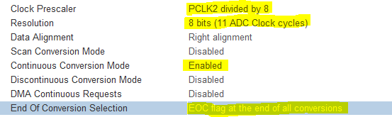

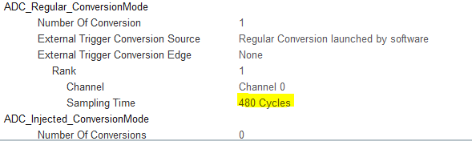

**NO DMA Required**

4. Now generate the code

5. Goto workbench and open main.c and make following changes

In user code begin 2 ---🡪

/* USER CODE BEGIN 2 */

HAL_ADC_Start(&hadc1);

/* USER CODE END 2 */

7. In user code begin 3 ----🡪

**while** (1)

{

/* USER CODE END WHILE */

/* USER CODE BEGIN 3 */

ADC_Value = HAL_ADC_GetValue(&hadc1);

}

/* USER CODE END 3 */

7. Compile the code and upload to board.